Exchequer Enterprise

DeliverANCe 2000 Interface

White House Products Ltd

Introduction
The Exchequer Enterprise DeliverANCe 2000 Interface allows orders to be imported into ANC’s DeliverANCe 2000 system for generating the ANC paperwork.

When the Interface is installed an additional button “ANC” is available on the Sales Order Daybook, when clicked it will check the order and then display the following dialog allowing the specification of various details needed by the ANC system.

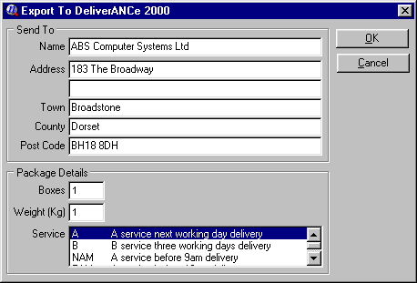
The Send To section is taken from the Sales Order and cannot be changed. The Address is taken from the Delivery Address of the Order, if that is not set then the Customers Address is used instead. The Customers addresses must be specified in the format shown in the Send To section above.

The Package Details section should be set by the user, and when completed the OK button should be pressed. The following progress window is displayed during the export and gives various status information. When the export is complete you will need to press the Close button to return to the Sales Order Daybook.

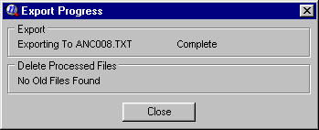

Installation
The Exchequer Enterprise ANC Interface is an add-on to Exchequer Enterprise, and requires an Exchequer Enterprise version of 4.22 or later.

The following files should have been supplied in a separate directory in the root of your Exchequer Enterprise CD.

ANCEXPRT.DLL | The ANC Interface add-on
ANCEXPRT.INI | The ANC Interface setup file
ENTCUSTM.INI | Exchequer Enterprise Customisation setup file
ENTDLL32.DLL | Exchequer Enterprise Utility Library
EXCHDLL.INI | Exchequer Enterprise Utility Library setup file
WHITEH01.DLL | White House Products Customisation Library

The following steps should be followed to install the ANC Interface, this should be done while no-one is using the Exchequer Enterprise system.

- Copy the supplied files to your main Exchequer Enterprise directory, this is the directory which will contain ENTER1.EXE.

2) Now you have to configure the DeliverANCe 2000 Interface. This is done be editing ANCEXPRT.INI. For details of the various settings see the ANCEXPRT.INI section later in this document.

The supplied ANCEXPRT.INI is already setup with the details given to us, all you need to change are the ANCPath and ANCContractNo entries in the [Settings] section.

You should also check the [DefaultCodes] section where your internal codes are mapped into the ANC Service Codes, in particular your ‘AC’ code could not be mapped onto any ANC Code from the description you gave us, so it is currently setup to default to the first service code in the list.

- Once you have configured the DeliverANCe 2000 Interface you can run Exchequer Enterprise. If you go into the Sales Order Daybook you should see a button ‘ANC’ at the bottom of the list of buttons, this button triggers the export to DeliverANCe 2000.

ANCEXPRT.INI
The ANCEXPRT.INI file is used to store the configuration settings for the export and is divided into the following sections.

Settings
This section contains various miscellaneous settings used by the interface.

[Settings]
ANCPath=C:\ANC\
ANCContractNo=A7846B98

The ANCPath specifies the directory that the export files are to be placed in. It must be a full drive and directory path, in MS-DOS 8.3 format, which exists for the computer running the export.

The ANCContractNo is your Contract Number with ANC.

DefaultCodes
This section contains a list of the codes that will be present in the Order’s User Field 1, these codes are used to identify the Sales Orders which should be processed by the interface. It can also be used to specify a default ANC Service Code for each of your codes, this is then used as the default Service Code on the export dialog.

[DefaultCodes]
NumDefaults=3
Def1="10-TAM"
Def2="12-TN"
Def3="A3-"

NumDefaults is the number of Default Codes you are going to specify, if set to 0 it will disable the default checking and all Sales Orders will be processed by the Interface.

Each Defx entry, where x is a number, specifies one of your codes which will be present in the User Field 1 of the Sales Orders. Each entry must be in the format “AA-BBB” where AA represents your 2 character code, and BBB represents the ANC Service Code the dialog should default to. If BBB is blank or does not represent a valid ANC Service Code then the first entry in the Service Codes list will be selected automatically.

ServiceCodes
This section contains a list of ANC’s Service Codes and their Descriptions, these are used in the list on the export dialog. The supplied ANCEXPRT.INI is already setup with all known ANC Service Codes.

[ServiceCodes]
NumCodes=4
Code1=A -A service next working day delivery
Code2=B -B service three working days delivery
Code3=NAM-A service before 9am delivery
Code4=TAM-A service before 10am delivery

NumCodes is the number of ANC Service Codes you are going to specify.

Each Codex entry, where x is a number, represents one ANC Service Code and must be
specified in the format shown above.

DeliverANCe 2000 Interface Modifications

Customer and Supplier Lists
A button will be added to both the Customer List and Supplier List in the Trader Window to display the existing “Export To DeliverANCe 2000” window. The window will be loaded with the details from the Customer/Supplier and the Boxes, Weight and Service fields will be manually entered. Two new fields will be added to allow the ANC Delivery Reference fields to be specified.

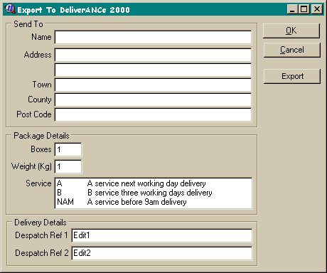

Exporting Delivery Addresses
A new button Export will be added to the “Export To DeliverANCe 2000” window which will export the Name, Address, Town, County and Post Code fields to a CSV format file in the Exchequer Enterprise directory. If the file already exists the details will be appended to the end of the file, otherwise a new file will be created containing the details.

